Question set 1

1. Genus is the parent class of Species. Species class inherits variable ‘g’ from Genus Class.
2. Species is the parent class of Specimen. From specimen class, we can access through Genus and Species class.

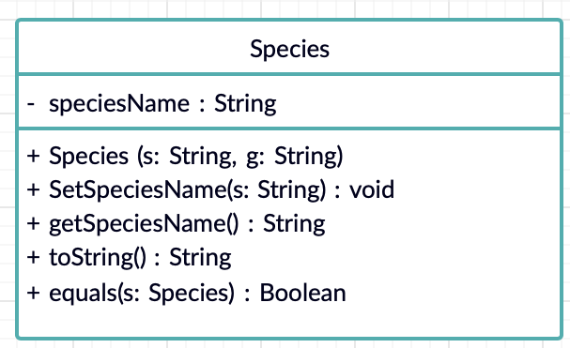

2. 1. No need to duplicate the same function with the code because of inheritance.

2. It is more faster to develop a program.

1. (i) It is working based on the class declared by the object.

(ii) Overriding

Question set 2

1. practice of hiding the structure and representation of data within a class and making it accessible outside that class via accessor functions
2. 1. If there are changes to the data, only the class that needs to be changed

2. It can provide the programmer to hide the inner classes and the user to give access only to the desired codes.

1. getName() , getCage() , getTOA()
2. name , cageNumber , toa

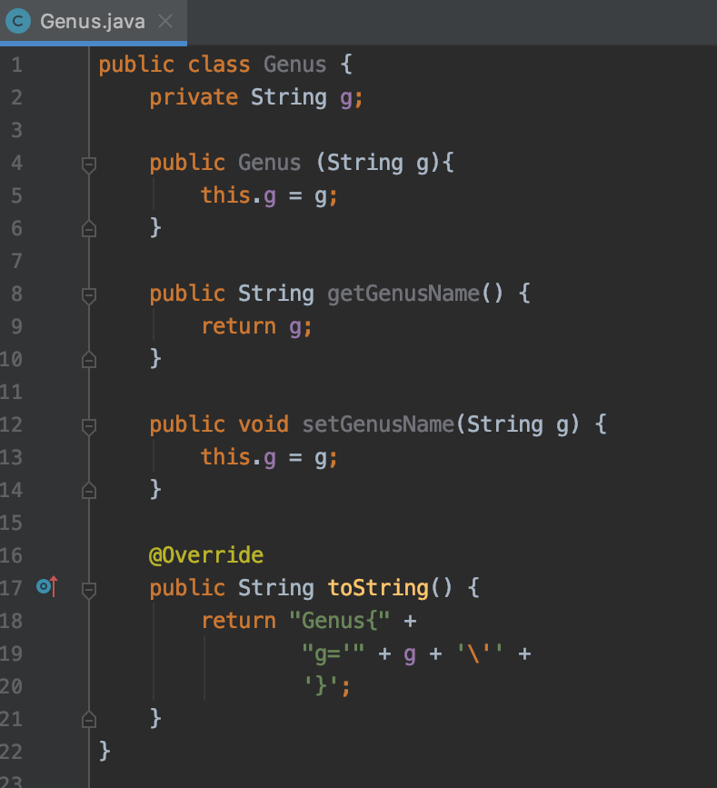

1. Advantage = We can access the Genus and Species class by using the same object because Specimen inherit both Genus and Species class.

Disadvantage = Not all methods and variables are consistent between all specimens;

This means that changes made to methods or variables in the Species class may not apply to all specimens

Question Set 3

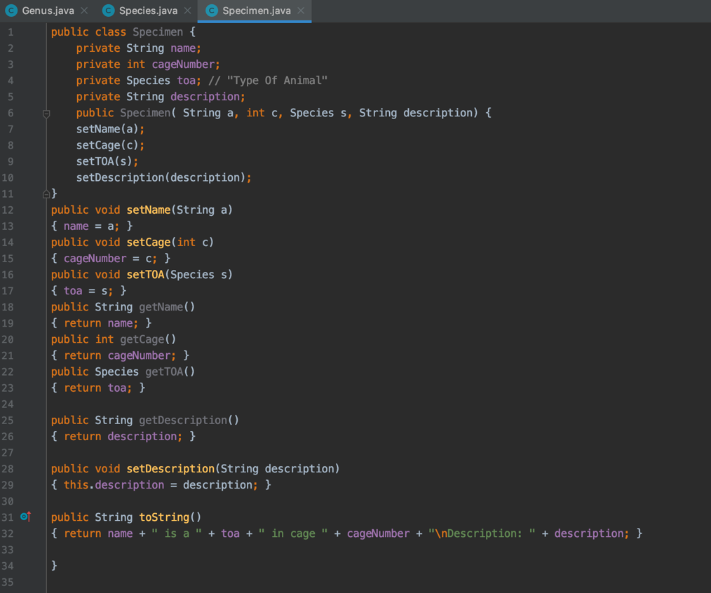

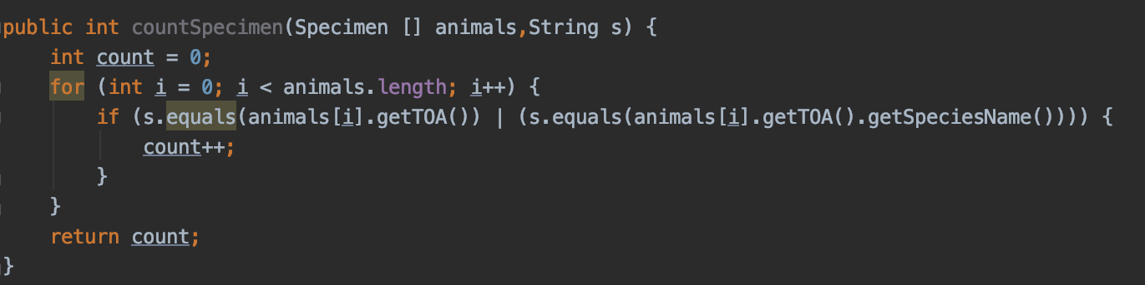

Question Set 4

1. In abstract class method, no implementation details are known.

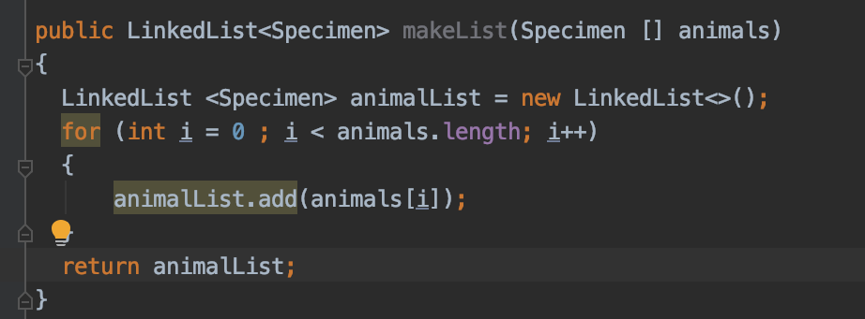(b)

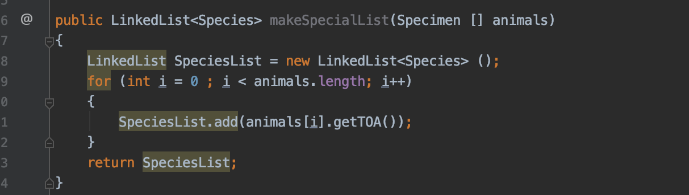c.

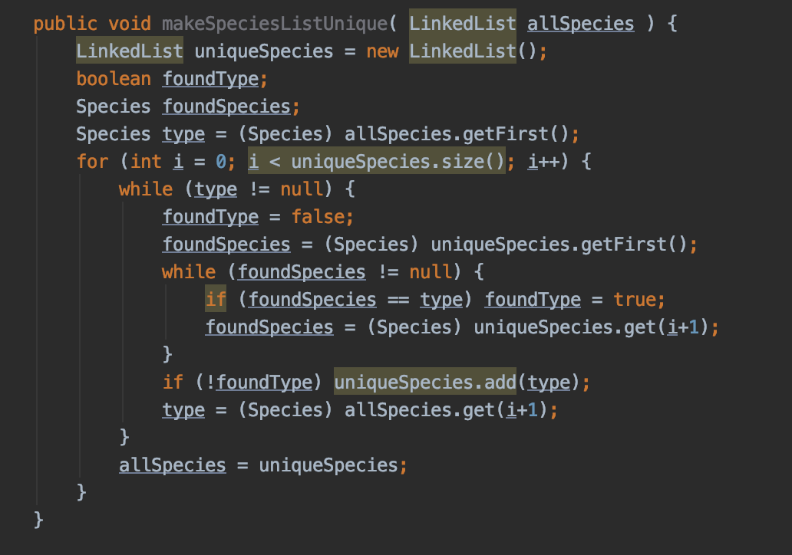

d.